Certificate Covering Letter: Offer letter for the deposit
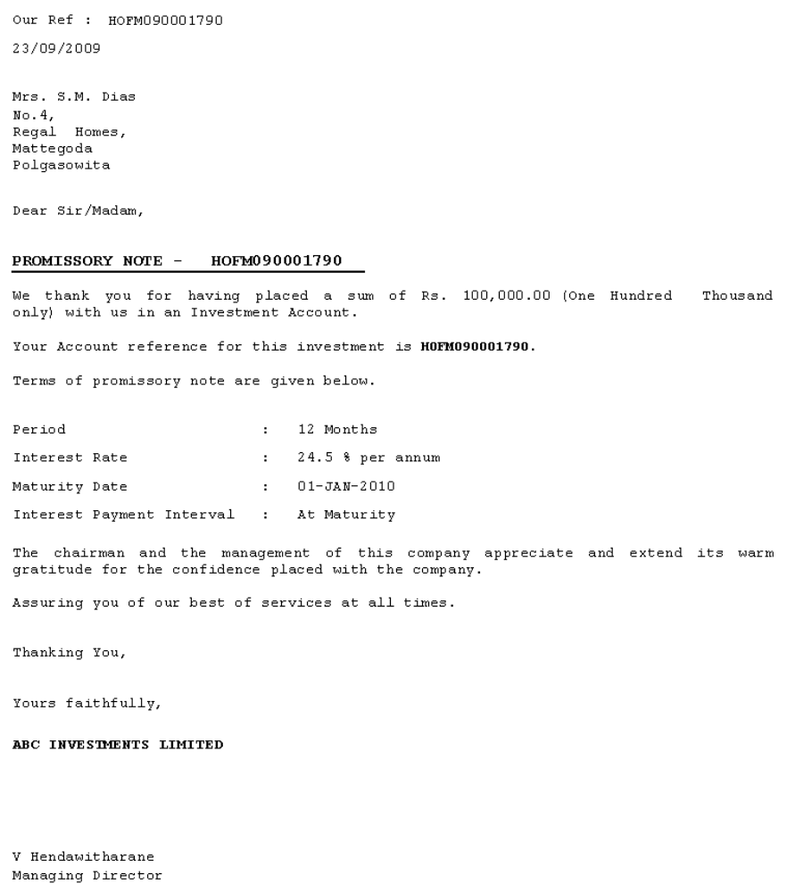

Renewal Notice: Sending renewal notice at maturity and calculation gap interest for the period
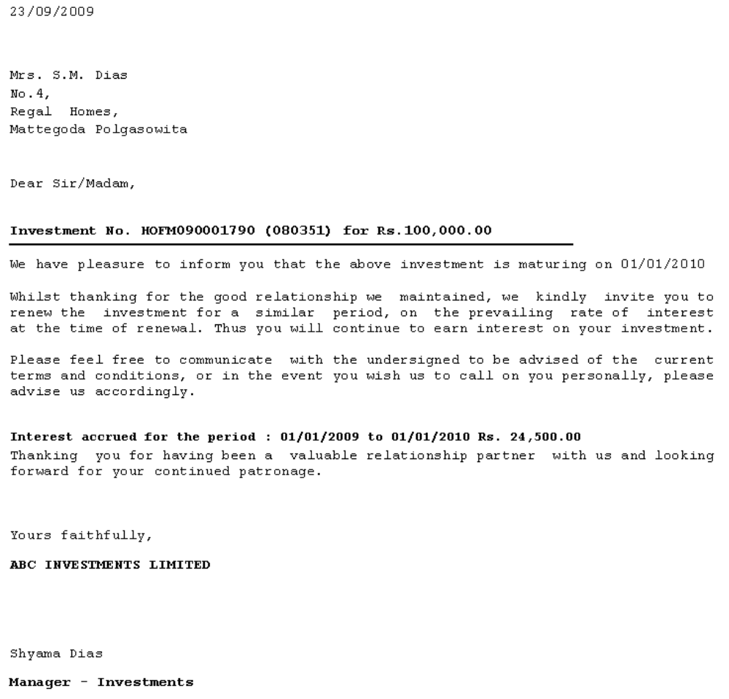

Master Schedule: Scheduling interest payment for the deposits

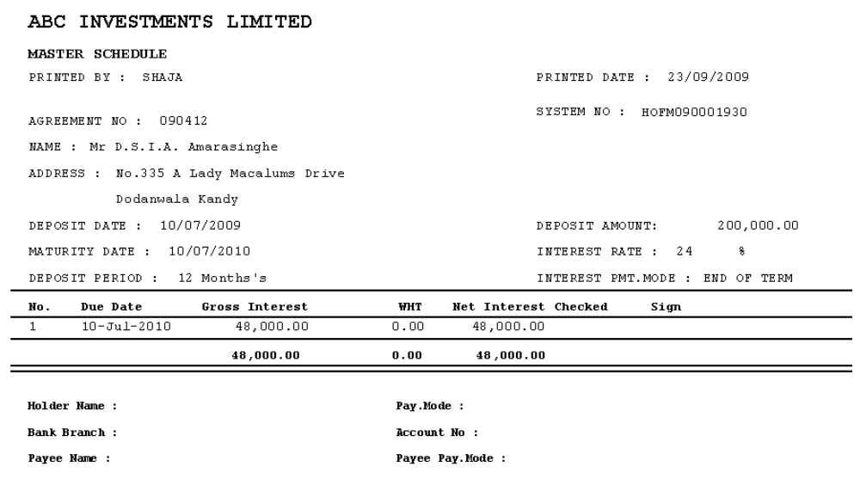

Auto Renewal Letter: If advised for auto renewal, this letter will be generated

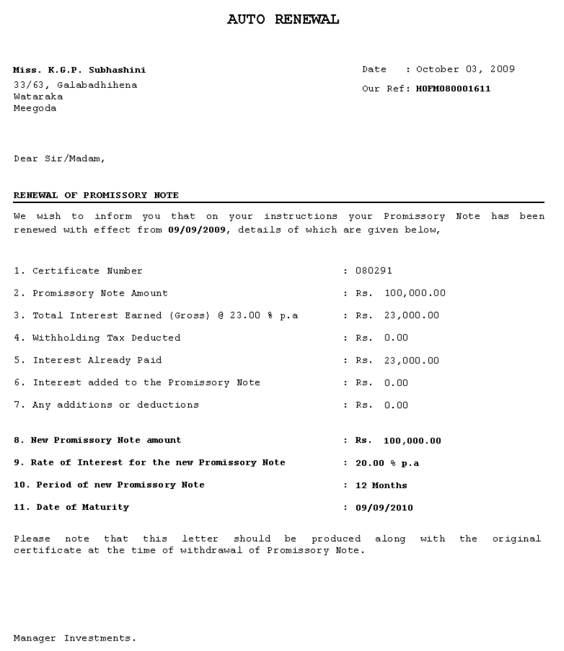

Certificate Printing: Certificate printing on a preprinted format for the deposits

Warrant Payment Details

Warrant Payment Details – Payment Type wise

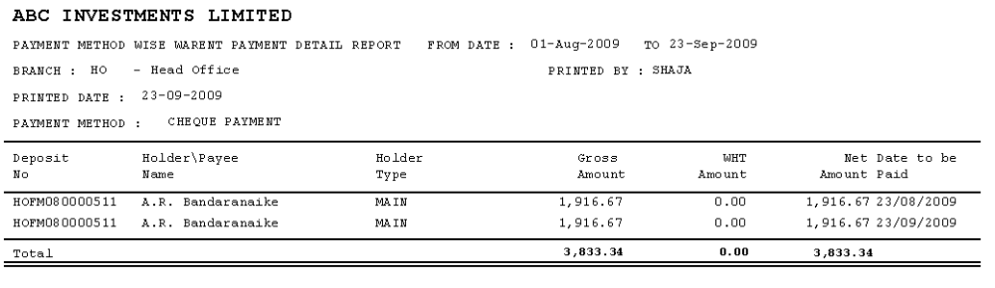

Active Deposit Base Analysis
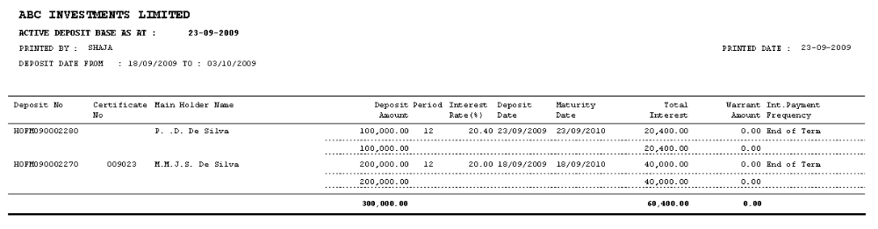

Deposit Maturity Details
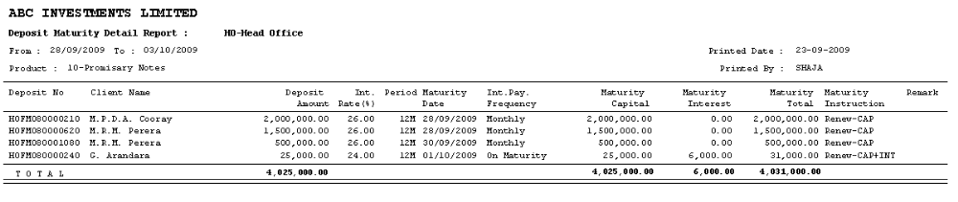

Interest Payment for the Given Period
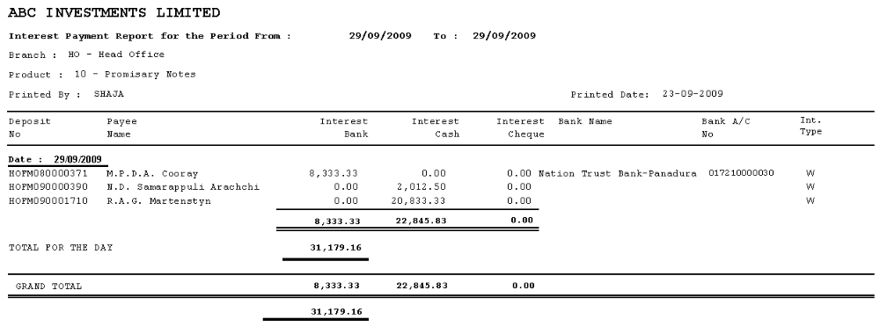

Closure Report

